Team name: Team UTSC

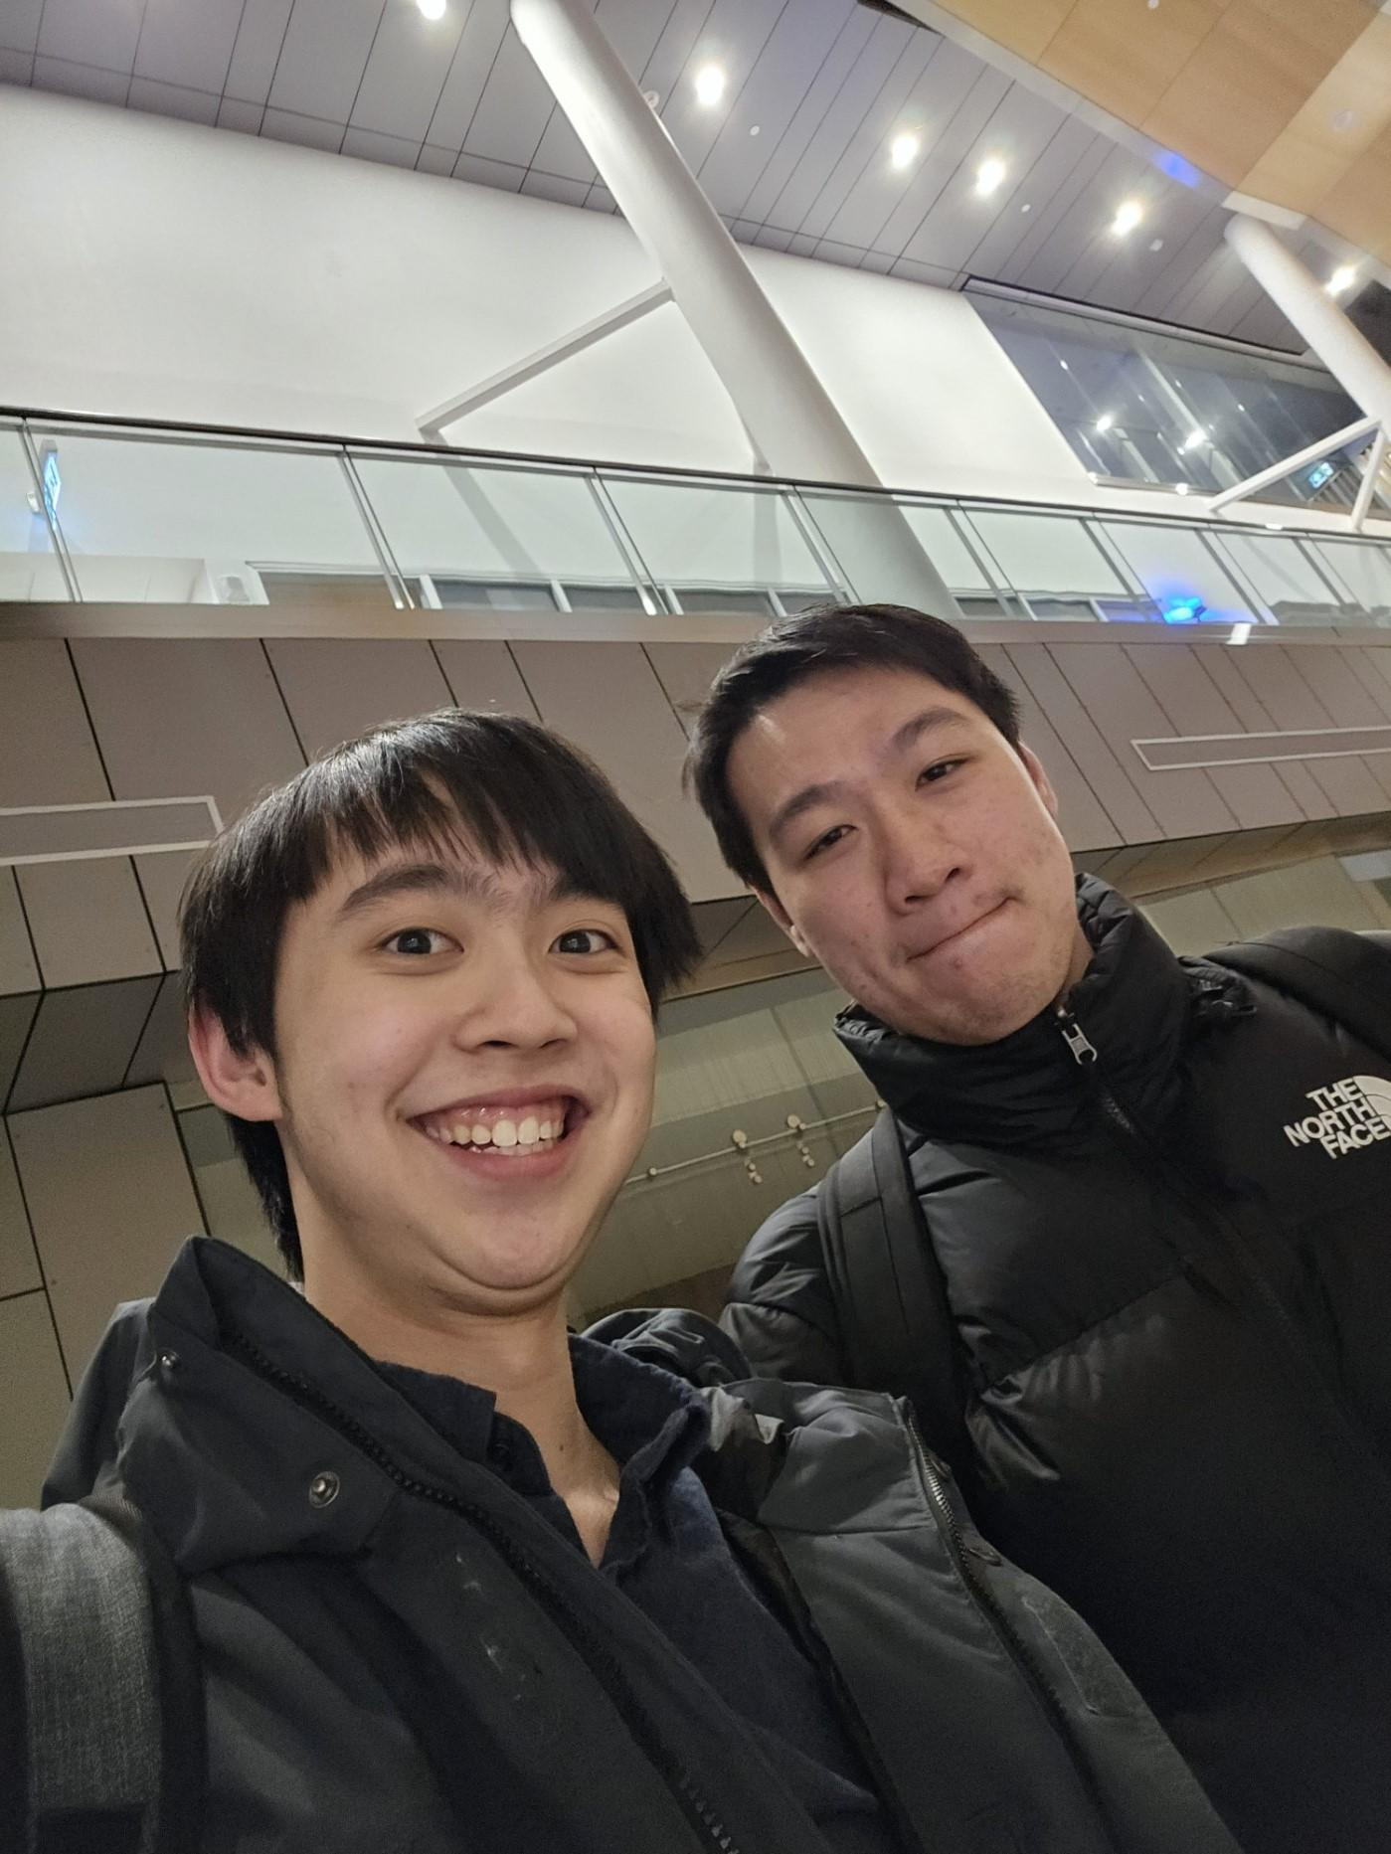

Team member 1: Max Chueng (left)

I am a third-year student in UTSC currently majoring in cities studies, physical and human geography as well as a minor in geographic information systems. I focus more towards urban planning and transportation planning within the Greater Toronto Area. I have been using GIS to create choropleth maps as a data visualization tool and I hope to be able to further utilise GIS in advocating for better transportation options in the GTA and to analysise ongoing issues related to housing affordability and congestion in the future.

Team member 2: David Huang (right)

I am a fourth-year student at UTSC, and I am currently doing a double major in Cities Studies and Public Policy as well as a minor in Geographic Information Systems. I have an interest in using GIS to map out and analyze urban environments to really understand why certain policy decisions are being made. In particular, the planning fields that I have an interest in includes transportation, housing, and environmental planning. I hope that I will be able to bring my skills to a workplace where I can contribute to the development of sustainable and inclusive city.

Project: https://experience.arcgis.com/experience/85db64b90e144501a5d882b7d69a0a23/